Coursework Coversheet

|  |  |  |  |
| --- | --- | --- | --- |
| Module: | Computer science | Term: | 3 |
| Date: | 8/5/2025 | Weighting: | 30% |
| Student First Name: | Akihiro | | |
| Student Last name: | Tajima | | |
| Course Tutor: | Claudia Papi | | |
| Class: | Computer science 1 | | |

­­­­­­­­­­­­

Marks Obtained (out of 100):

Grade:

*Declaration that the work submitted is my own. I:*

×　declare that this submission is entirely written in my own words and no part has been

generated by AI software.

* declare that this submission has been written with contributions from AI software.

I acknowledge that-

* used AI for suggestions, generate ideas or understand core concepts as a preparatory activity
* used AI to write, rephrase, or paraphrase part of the essay
* used QuillBot, Grammarly or other software to review language

At the end of the reference section, list AI tools used and explain how much (in percentage) they have contributed. Failure to acknowledge use of generative AI tools (such as ChatGPT and Bard) is considered a violation of EF’s plagiarism standards.

**Project 4: weather wardrobe assistant**

**Introduction**

I choose the project 4 as my final project. It required to use python coding, and I thought python is one of main topics in what I learned in this course, therefore it was really suitable for me. The object of this project 4 is that providing the suggestion of clothes for uses based on the given information about temperature and climate (rain, wind). Regarding the function of this system, firstly users needed to log in the system by using their personal ID and password (in this case, I set up by myself.), then, enter the information about temperature and climate, finally user gets the suggestions based on the information. Just in case, it includes the system to make them sure to enter the information before, when they jump the step to get the suggestions.

**Outline**

In project 4, most of things used was what I have learned throughout the course, therefore, nothing special to research by myself. Mainly, ‘while loop’, ‘if’, ‘elif’ and ‘else’ conditions were used as function of this coding. Those are really simple and introductory elements of python, but they have very important roles and it is possible to present widen range of functions by assembling correctly. As the additional codes, function of ‘time.sleep’ and ‘clear_output’ were used in my project. Those are not appeared throughout the course, however, to make my project better, I thought it would be useful code and I researched by myself.

Those are the description of two function.

**time.sleep**

-Import the function

It is the standard library of python such as math, random and so on , so those are needed to be imported to own coding like below.



import + the name of function.

-As the way to use it, this code below is needed.



The number (2) shows the time to wait the following coding.

**Clear_output**

-import the function

it is also external function; therefore, it has to be imported, but it is not standard library then other methos was needed to make it available in own coding.

-I made the code by using Google colab, and google colab has to use the specific function which is not used in normal python. Here is the code.



This means, the function ‘clear_output’ is imported from the module of ‘IPython.display’

that is valid for this case but normally it is not valid.

-As the way to use it



It is the same with ‘time.sleep’, in the case to call the function, nothing has to be placed in the brackets in this function.

However, to reduce errors in my coding. I used this below.



‘wait=True’ means that the function ‘clear_output wait for the ready of following code. If it is not mentioned as shown in upper picture, wait=False is defined automatically and it does not wait to do ‘clear_output’, as a result, some errors can be happened. Therefore, I used ‘wait=True’ in my project.

**Problem happened in my code**

I faced the problem in my way to make the code. Here is the discriprion.

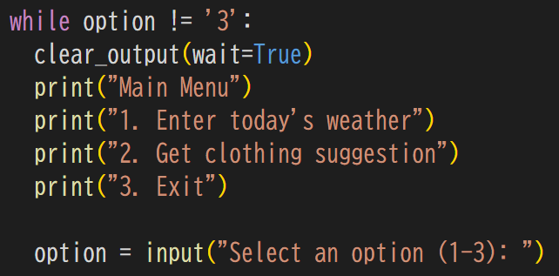

In the beginning, I coded like above picture, but one problem was happened in this code.

The output of this code was not stable, in first attempt to output it, it worked without problem, however, second attempt failed.

The line **‘option = input(“Select an option (1-3)”)’** did not work successfully. It was not appeared as the output.

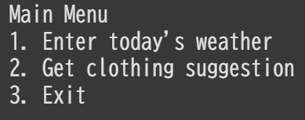

This is the actual output of above code.

I expected that **‘option = input(“Select an option (1-3)”)’** should be outputted, but there was not it.

**Solution**

As the reason for that, I find out the function **’clear_output’** is likely to happen it. Therefore, I thought it would be correct and I put the function **‘time.sleep(1)**’, then it takes a rest in one second to output **‘option = input(“Select an option (1-3)”)’**. As the result, it won’t be deleted by **’clear_output’**, then, output worked successfully.

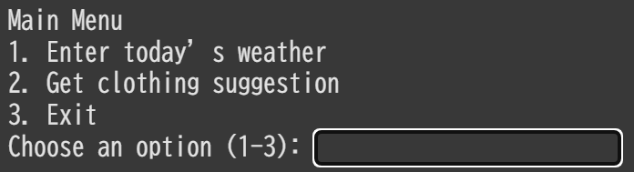

**Outcomes**

Finally, my code works well to meet the condition which is told in the guideline of final project. It has not functional problem to make suggestion to users. User can try to log in the system up to 3 times, then, if they log in the system, they enter the information of temperature and climate, and they can get suggestions based on the information. Overall, I can say it is successful.

**Improvement**

Codes I used in this project such as ‘while loop’, ‘if’ are really simple and introductory functions, so I want to use more further functions to make code more concise, and it would be needed in further study of computer science. In next opportunity, I want to challenge those.